FOR IMMEDIATE RELEASE

Loughney Wins Innis Maggiore Endowed Scholarship for Communications

CANTON, Ohio (Oct. 4, 2016) — Innis Maggiore President and CEO Dick Maggiore today announced that Kent State University at Stark senior David Loughney was awarded the Innis Maggiore Endowed Scholarship for Communications.

A Hartville resident and Lake High School graduate, Loughney is majoring in applied communications with a focus on public relations and media management. He is interning at Kent State Stark’s Career Services, where he is assisting with marketing and advertising. Loughney is the officer of publicity for Revive, an on-campus student organization, and recently completed an internship with East Nimishillen Church of the Brethren where he served as a media manager and graphic designer for the ministry. He is also a sales associate at T.J. Maxx in Belden Village.

“I’m paying for my college education out of my own pocket and it is a challenge to balance a work schedule as a full-time student,” Loughney said. “This scholarship will relieve some of the financial stress and allow me more freedom to experience real-life opportunities that will benefit me in my future career.”

After graduation, Loughney plans to pursue a career in a ministerial organization where he can use his public relations and management skills to connect members to the community.

“We believe that our investment in tomorrow’s workforce will help our community to continue to grow and prosper,” Maggiore said. “Our agency proudly supports students like David, who set goals and work hard in and outside of the classroom.”

Innis Maggiore originally endowed the scholarship in 2007. This year, $1,750 was distributed to the scholarship winner. Full-time Kent State Stark students who reside in Stark County, major in communications, marketing, public relations, journalism or advertising, and demonstrate need are eligible for the annual scholarship. For more information, visit www.stark.kent.edu/scholarships.

Innis Maggiore Group is the nation's leading positioning agency, building strong brand positions for companies in competitive markets. The full-service integrated agency had 2015 capitalized billings of more than $23 million. Key clients include: Aultman Hospital, Baird Brothers Fine Hardwoods, Bank of America, Campbell Oil/BellStores, DRB Systems, FSBO.com, GOJO Industries (Purell), The Goodyear Tire & Rubber Company, GuideStone Financial Resources, KFC/Kendall House, Kimble Companies, MCTV, Marathon Petroleum Corporation, Nickles Bakery, Republic Steel, SmithFoods and Stark Community Foundation. The company maintains a website at www.innismaggiore.com.

###

For more information:
Jack Wollitz, Senior Director Digital Content
Innis Maggiore Group, Inc.
330-492-5500 or 800-460-4111
jack@innismaggiore.com

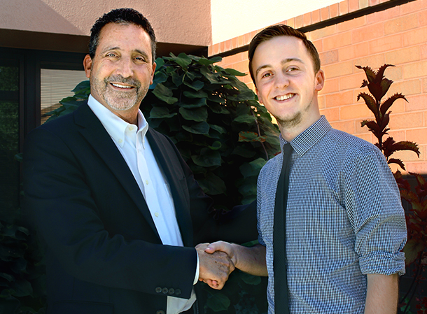

Kent State University at Stark senior David Loughney is the 2016-2017 recipient
of the Innis Maggiore Endowed Scholarship for Communications.
The Hartville resident and graduate of Lake High School is majoring in applied communications
with a focus on public relations and media management.
He plans to pursue a career with a ministerial organization.

