FOR IMMEDIATE RELEASE

Farley Awarded Innis Maggiore Endowed Scholarship for Communications

CANTON, Ohio (July 31, 2017) — Innis Maggiore President and CEO Dick Maggiore today announced that Kent State University at Stark senior Paul Farley was awarded the Innis Maggiore Endowed Scholarship for Communications.

A marketing major, Farley is a nontraditional student who returned to college after a five-year break. He is the marketing director at Retain Loyalty and also runs his own business, Optimum Designs, a web design company. His future plans include real estate investing and possibly opening a brokerage.
Farley lives in Perry Township with his fiancé and daughter, and also has a son on the way.

“This scholarship has been a godsend to me,” Farley said. “The award came at just the right time as it will help me cross the finish line to earn my degree.”

Maggiore said Innis Maggiore is proud to invest in tomorrow’s workforce. “We believe our support will help the community grow and prosper. Paul’s dedication to his education is commendable, and we appreciate his passion for marketing — particularly his expressed interest in positioning strategy.”

Innis Maggiore originally endowed the scholarship in 2007. This year, $1,750 was distributed to the scholarship winner. Full-time Kent State Stark students who reside in Stark County, major in communications, marketing, public relations, journalism or advertising, and demonstrate need are eligible for the annual scholarship. For more information, visit http://www.kent.edu/stark/stark-scholarships.

Innis Maggiore Group is the nation's leading positioning ad agency, building strong brand positions for companies in competitive markets. The full-service integrated agency had 2016 capitalized billings of more than $23 million. Key clients include: Aultman Hospital, Baird Brothers Fine Hardwoods, BellStores, DRB Systems, FSBO.com, GOJO Industries (Purell), The Goodyear Tire & Rubber Company, KFC/Kendall House, Kimble Companies, MCTV, Marathon Petroleum Corporation, Mid’s Sicilian Pasta Sauce, Nickles Bakery, Republic Steel, SmithFoods and Stark Community Foundation. The company maintains a website at www.innismaggiore.com.

###

For more information:
Jack Wollitz, Senior Director Digital Content
Innis Maggiore Group, Inc.
330-492-5500 or 800-460-4111
jack.wollitz@innismaggiore.com

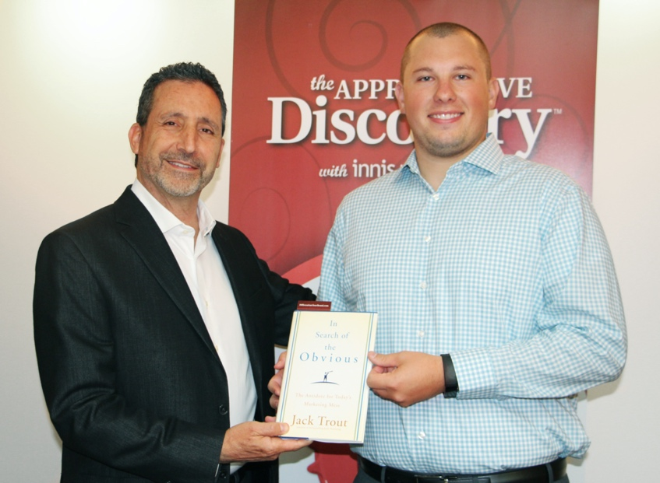

Dick Maggiore, president and CEO of Innis Maggiore (left), presented Paul Farley,
winner of the Innis Maggiore Endowed Scholarship for Communications, with
In Search of the Obvious, by the late Jack Trout, the Father of Positioning and a friend
of the agency. A marketing major, Farley is a senior at Kent State University at Stark.

