FOR IMMEDIATE RELEASE

Innis Maggiore only Stark County agency awarded Gold at Akron ad competition

CANTON, Ohio (Feb. 26, 2018) — Innis Maggiore, the nation’s leading positioning ad agency, today announced that it earned one Gold and four Silver awards at the 2018 American Advertising Federation Awards (also known as the ADDY® Awards) ceremony Friday night at the Akron Civic Theater. Innis Maggiore was the only Stark County agency to be honored with a Gold award at the ceremony.

Held by the Akron Chapter of the American Advertising Federation (AAF-Akron), the ceremony featured entries from Akron, Canton and the surrounding areas.

Innis Maggiore’s Gold ADDY was earned for its work on the Artisa website (ArtisaBrand.com) in the “Consumer Website” category. Innis Maggiore received the only Gold award in the “Website” categories.
The agency’s four Silver ADDY Awards were earned for its work on:
- The Maximal Strategist website (MaximalStrategist.com) in the “Business to Business Website” category;
- The Artisa multipack package for Sam’s Club in the “Packaging” category;
- The Artisa trade show banners in the “Out of Home Campaign” category; and
- The Smith’s website photography in the “Still Photography Campaign” category

“Innis Maggiore is privileged to collaborate with clients resulting in award-winning work,” said Dick Maggiore, president and CEO. “But even more important, is to produce work that helps them succeed and grow in their highly competitive markets. We’re truly honored to be the only Stark County agency to be recognized with a Gold award at this year’s AAF-Akron competition and the only Gold in the ‘Website’ categories.”

Innis Maggiore Group is the nation’s leading positioning ad agency, building strong brand positions for companies in competitive markets. The full-service integrated agency had 2017 capitalized billings of $27 million. Key clients include: Aultman Hospital, AultCare, Baird Brothers Fine Hardwoods, BellStores, DRB Systems, Dr. Lite Medical Technologies, FSBO.com, GOJO Industries (Purell), The Goodyear Tire & Rubber Company, KFC/Kendall House, Kobre & Kim, MCTV, Marathon Petroleum Corporation, Mid’s Sicilian Pasta Sauce, Nickles Bakery, Nilodor, Republic Steel, Senseonics, SmithFoods and Stark Community Foundation. The company maintains a website at InnisMaggiore.com.

For more information:
Jim Cyphert, Public Relations Director
Innis Maggiore Group, Inc.
800-460-4111/330-501-9886 (cell)/jim.cyphert@innismaggiore.com
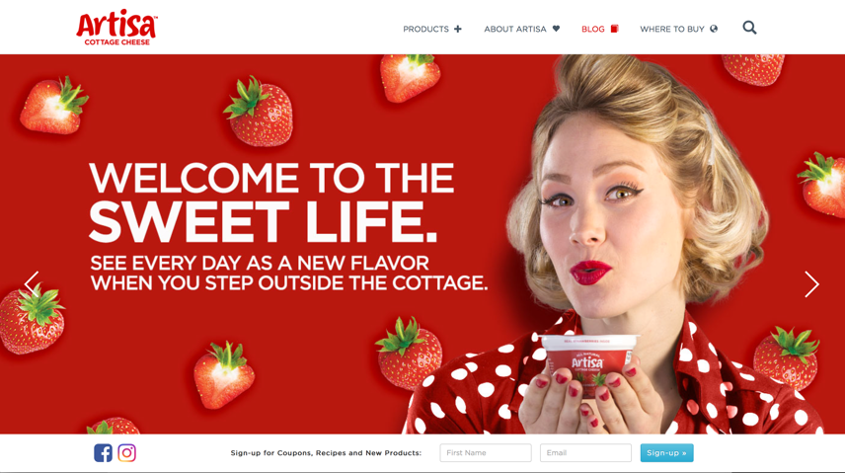

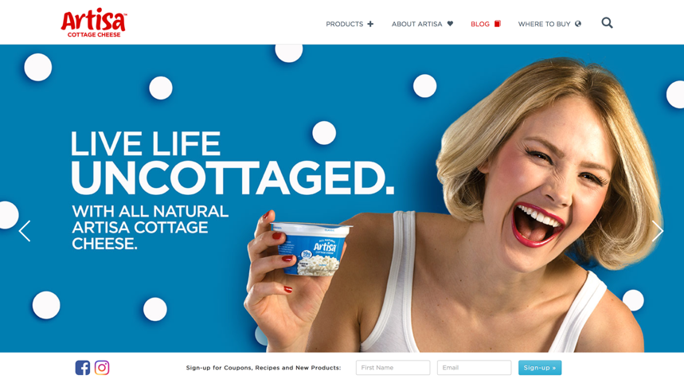

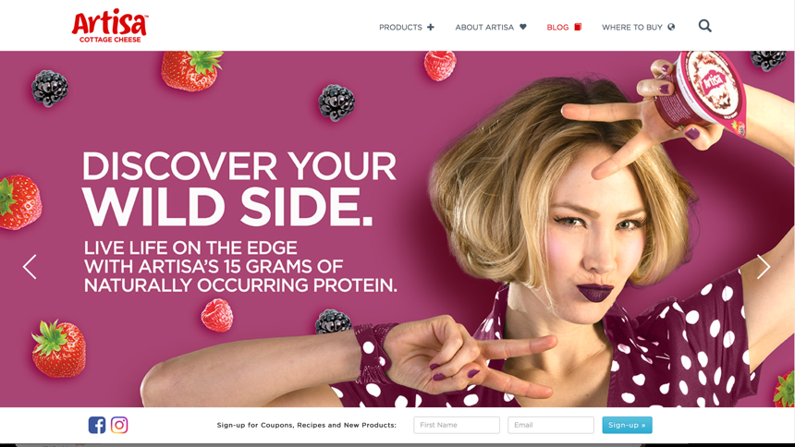

Screen shots from Innis Maggiore’s Gold ADDY Award-winning Artisa website.

###

